**Printer issue- ZEBRA TTP2030**

Table of Contents

1. **Troubleshooting summary and hotfixes2**
2. **Printer settings3**
3. **Zebra drivers and utility software10**

Drivers10

Spooler11

1. **Zebra toolbox12**
2. **Email with printer basic check request12**
3. XML settings

**Troubleshooting summary and hotfixes:**

1. **Is the printer being detected in “devices and printers”**
2. **Printer is detected and shows green tick sign- Continue troubleshooting**
3. **Printer shows as “unknown device”-**

-Solution: Ask cinema to reset the cables and reinstall drivers.

1. **Printer is being detected however it has a warning status:**

**-**Solution: Apply fix accordingly to issue displayed on the printer. Most common issue is paper jamming/out. Check template with basic checks.

1. **What happens when running “test print”:**
2. **Printer jammed**

-Solution: check the settings, if it makes grinding noise or keeps jamming with correct settings this is a hardware issue. Ask cinema to check printer paper.

1. **Printer will print only on administrator/ vista will crash but printer is fine**

**Solution:**

-Check the name of the printer

-check the security settings on the printer

-Check xml settings

1. **All working fine on admin but printer keeps printing blank pages**

-Solution: Check printer configuration on ocius

[(You can find it in my guide 2.ATM_PED_guide_v1.2 in section 4. Configure ocius)](2.%20ATM_PED_guide_v_1_2.docx)

1. **Common issues**

This is the most common printer. It’s attached in Neo V1, V2 and ProTouch ATMs.

This is how printer without any issues should look. The red bracket is the space that will display errors details.

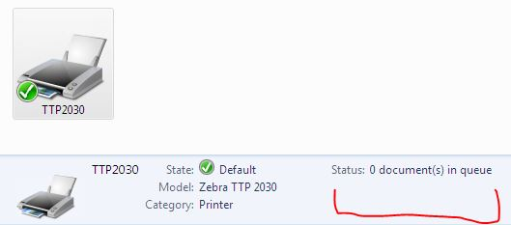

Most common errors are:

-Paper jammed.

This error will usually crash vista at start.

In this case you should call the site and ask the manager to check the printer for any jams/ trash hindering printer.

-Toner/ink low

The printer does not use toner. However this error may suggest that printer is not configured properly.

-Printer has disconnected:

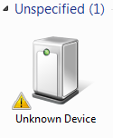

Solution:

-Disconnect the printer by unplugging the usb cable and plugging it back in.

- Right click on “Unknown device”, go to hardware, properties, driver, uninstall.

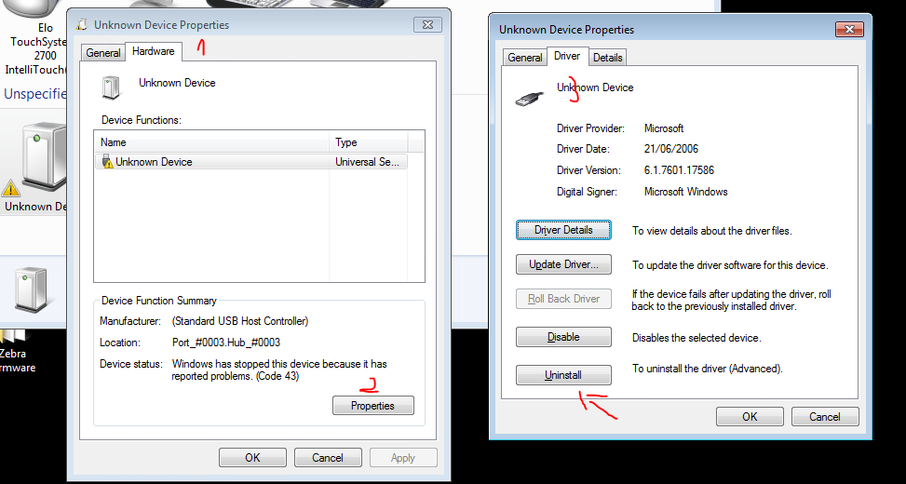

After that go to device manager, right click on anything and select “Scan for hardware changes”

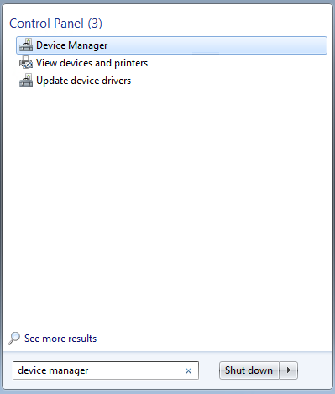

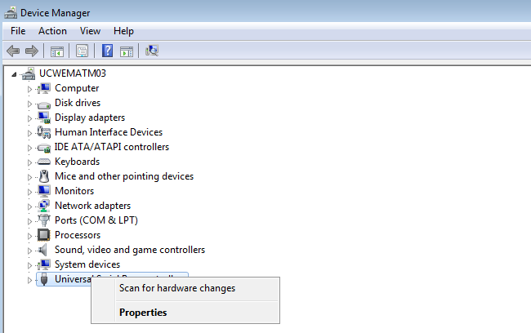

After that you will see if the device drivers were successfully installed.

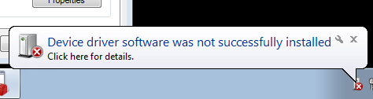

1. **Printer settings**

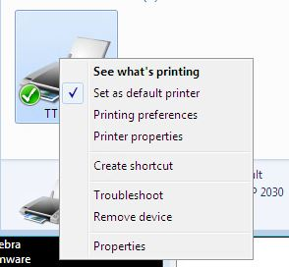When printer is causing any issues check if the settings are correct by right clicking on printer and going to “printer properties”

In General tab:

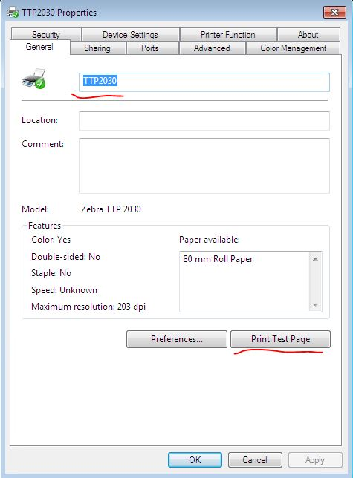Name of the printer should always be TTP2030

From default this is set as Zebra TTP 2030 -

If this is the case printer won’t work on VISTA

You can also check if printer is still jamming by printing test page

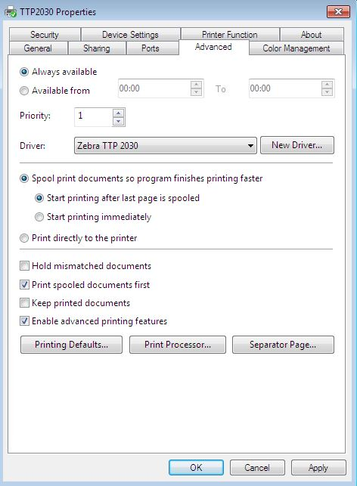In Advanced tab:

For Zebra TTP2030 proper settings are **“spool print documents so program finishes printing faster”**

And

**“start printing after last page is spooled**”.

Other settings may cause printer issues – please bear in mind that this setting is using windows spooling services so you need to make sure this service is running.

In case if there are some problems with the service you may set **“Print directly to the printer”.**

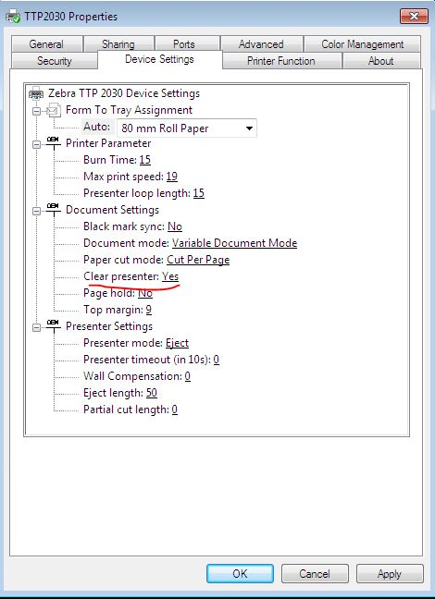In Device Settings tab:

You should check if clear presenter is changed to “Yes”. This is set up for purpose to let the printer clear the presenter and ‘spit’ the ticket out of the printer roll to make sure the printer won’t jam if there are other tickets printed in the same transaction.

In Security tab:

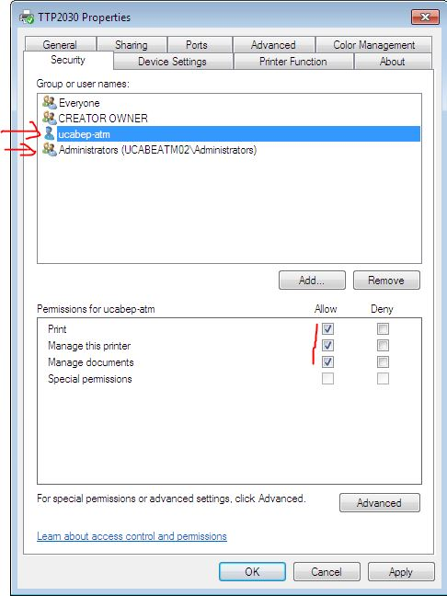User account and administrator should have all permissions allowed. This is simply because otherwise the users won’t be permitted to print using that printer.

After all has been checked press apply.

If all settings are correct and you are able to print test page check settings on ocius (go to part 1.)

1. **Zebra drivers and utility software:**

**Zebra TTP drivers**:

If the printer is being detected as unknown device or is causing other software related issues on administrator it can be fixed by reinstalling drivers.

Log off user

Uninstall Zebra driver

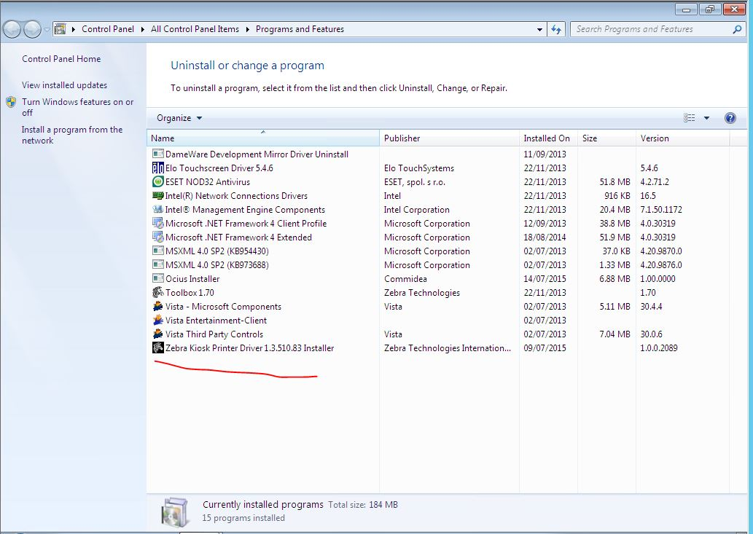

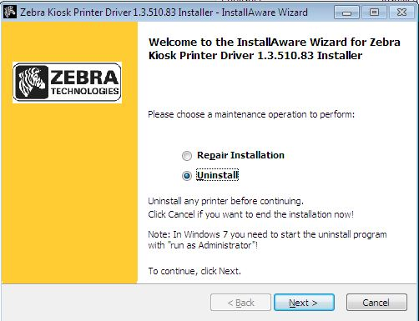

**Install zebra drivers**

Zebra drivers can be found on:

1. ATM in “C:\Windows\dwrcs\Uploads”
2. On another atm on the same site

\\ucXXXatmYY\c$\Windows\dwrcs\Uploads

Where XXX is site code and YY is ATM number

1. Viscin1 server

\\ucXXXp-viscin1\ where XXX is site id.

Simply as any other driver. Open the install file and go next. Accept the terms and conditions.

**Printer spooler** **C:\Users\dga\Desktop\atm guides\zebra\services.JPG**

If there are too many print requests and printer is jamming this may be fixed by going to:

Services. C:\Users\dga\Desktop\atm guides\zebra\services.JPG

Search for “Printer Spooler” and click “restart”.

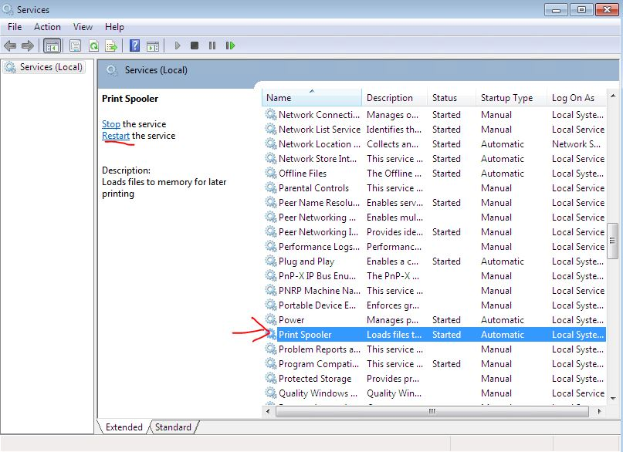

1. **Zebra toolbox:**

This is useful tool that can be found at:

C:\Program Files\Zebra\Toolbox

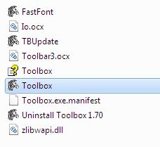

Run zebra and pick 210\216 mm

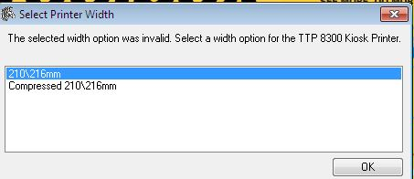

Go to port and select USB printer TTP 2030 Kiosk Printer

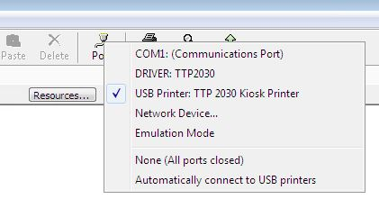

Go to “Tools” and select “Status Enquiry”

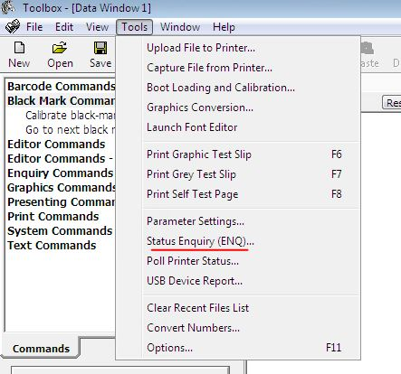

After that you can check detailed information about printer

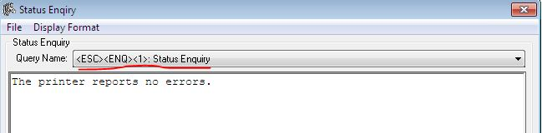

1. **Check request template for email:**

This is a template I have used when asking site for basic checks on printer:

Regarding issues with the printer on the ATM02.

Fixing this may be a challenge and we will need more information regarding this issue

Please try to do the following:

1. Ensure exit of the paper is lined up to the exit cut out in the front door. Failure to do so will result in paper jams and potentially damage to the printer :

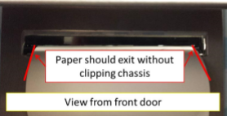

1. After that please do the following:

Please unplug usb cable that is in the back of the printer.

Plug it back in making sure it is firmly plugged in:

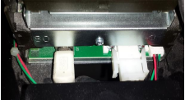

After that do the same to the end that goes to PC base unit.

Please note that this will set settings back to default and we will have to configure this again.

However this will help us make sure software is done well.

If this still does not work please check if the issue is with the chassis/ if the printer is adjusted incorrectly.

It may be that the brackt that holds printer is bent/ broken and this makes it drop down a little bit.

In this case it would be best to align it a little bit by putting paper under the printer in order to make it adjust better.

If the issue is to severe we can order company to adjust the bracket hovewer keep in mind that:

1. It is very costly so we do this as last resort
2. As its very costly we need solid evidence this is needed (pictures of broken bracket/ clear pictures of gat that is hindering atm from printing)
3. It will require long awaiting times
4. We still need exact information to do this as the company that will be ordered needs exacts guidelines what needs to be applied (do they need to hammer the part in order to adjust it or use special adhesive on bracket if its broken )

This is why it is better to try to adjust this printer by putting paper under it.

Lastly it may be that printer is missing the paper guide:

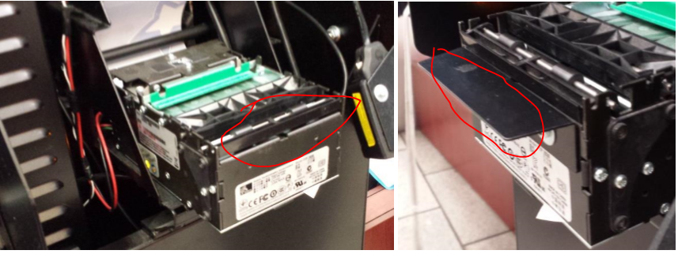

However this applies only to certain models of ATM’s.

Please let me know if part marked above is missing, if this is the case if its missing also on other ATM’s.

Thank you in advance for your help.

Kind regards

**Dawid Galeziewski**

**IT Service Desk Analyst**

**Cineworld Cinemas**

**d** 020 8987 5080

**e** dawid.galeziewski@cineworld.co.uk

**w** [cineworld.com](http://cineworld.com/)

1. **XML settings**

**VSSCLIENTHARDWARECONFIG**

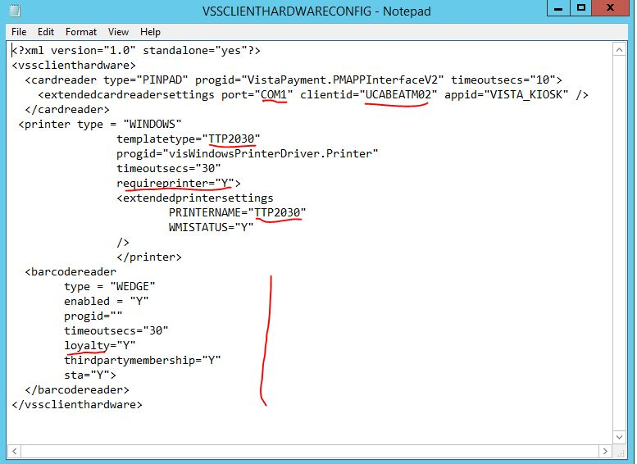**port**=”com1”

This should be the same for most sites

**Client id**

should always be:

UCXXXATMYY where

XXX- site code

YY- ATM number

**Template type** and **Printername**

This depends on printer connected to ATM. In most cases this will either be “STAR” or “TTP2030”

**Requireprinter**: this varies from site to site. If this is “Y” Vista will crash on start when printer will fail initializing

**Barcodereader:** on sites where ATM’s use loyalty, loyalty should be “Y”. if this is set to “N” or there is no string for this ATM’s won’t be able to use loyalty cards/